

1.Introduction
The Number Guessing Game is a classic interactive program where the user attempts to guess a randomly generated secret number within a specified range and a limited number of attempts. This report outlines the logic, program flow, and key components of such a game.
2. Game Logic
The core logic of the Number Guessing Game is as follows:
Random Number Generation: A secret integer is randomly generated within a predefined range (e.g., 1 to 100).
User Input: The player is prompted to enter their guess.
Comparison and Feedback: The player's guess is compared to the secret number.
If the guess matches the secret number, the player wins.
If the guess is too low, the player is informed that the secret number is higher.
If the guess is too high, the player is informed that the secret number is lower.
Attempt Tracking: The number of attempts made by the player is tracked.
Game Termination: The game ends when either the player correctly guesses the number or runs out of allowed attempts.
3. Program Flow
The program flow typically follows these steps:
Initialization:
Import necessary libraries (e.g., random for number generation).
Define the range for the secret number (e.g., lower_bound, upper_bound).
Set the maximum number of allowed attempts.
Generate a random secret_number within the defined range.
Initialize an attempts_taken counter to zero.
Game Loop:
A loop continues as long as attempts_taken is less than max_attempts and the secret_number has not been guessed.
Inside the loop:
Prompt the user for their guess.
Increment attempts_taken.
Compare the guess with the secret_number:
If guess == secret_number: Display a win message and break the loop.
If guess < secret_number: Display "Too low!"
If guess > secret_number: Display "Too high!"
Game End:
If the loop finishes because the secret_number was guessed, display a congratulatory message including the number of attempts.
If the loop finishes because attempts_taken reached max_attempts without a correct guess, display a "Game Over" message and reveal the secret_number.
Implementation:
Input
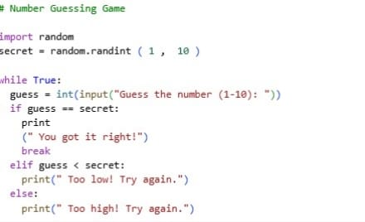
Output
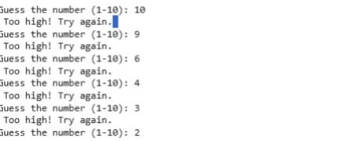
Future Prediction & Enhancements:
Future trends and potential enhancements to a simple number guessing game could include:
Advanced User Interfaces: Moving beyond the console to web-based interfaces using HTML/CSS/JavaScript or dedicated game engines for richer graphical and sound experiences.
Artificial Intelligence/Machine Learning: The computer's "guessing" ability (if it plays against a human) could be improved using machine learning models (like LSTMs) to predict patterns in the user's choices, making the AI a smarter opponent.
Improved Randomness: While PRNGs are sufficient for this game, the future may bring easier access to true random number generators (TRNGs) for applications requiring high security or unpredictability.
Multiplayer and Online Integration: The game could be extended to allow multiple users to play against each other online, incorporating networking code and databases for tracking high scores.
Voice Integration: Using speech recognition technology to allow users to play the game with voice commands instead of typing.

